**Functional Document**

|  |  |
| --- | --- |
| **Application** | NGERP – Cenrta |
| **Service Bundle** | Purchase Management |
| **Service Request** | NTA Purchase Order |

**Description:**

The NTA Purchase Order in **Compiere (NGERP - Centra)** defines key parameters in the Order Header that control the processing of order lines. Accurate header data ensures smooth procurement flow.

**Workflow Process:**

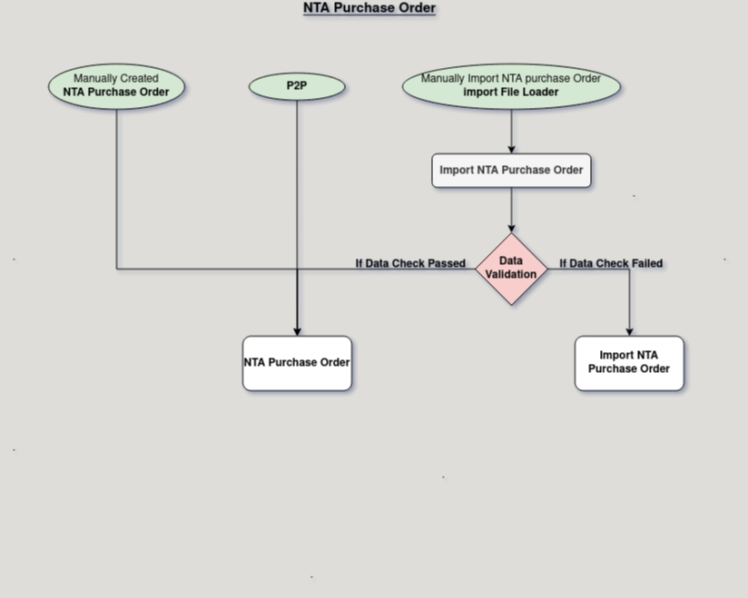

**Business Rules:**

* It is visible only in **HQ.**
* **Creation** is also possible in **HQ.**
* Define vendor, order date, and terms in the Order Header.
* Do not modify the "NTA Purchase Order" window name.
* Header details automatically apply to order lines.
* Ensure accurate vendor data for processing.